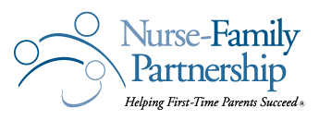

2019 TEXAS CAREGIVER OF THE YEAR AWARD – NFP COMMUNITY CHAMPION

NFP Community Champions can be volunteers, advocates, program staff, administrators, Community Advisory Board members, or other individuals from your community who believe in the mission and vision of Nurse-Family Partnership and have demonstrated extraordinary leadership and support for Nurse-Family Partnership in your community.
I nominate the following Community Champion as a deserving recipient of the 2018 Tenacious Caregiver of the Year Award. This Texas Community Champion exemplifies the mission and vision of Nurse Family Partnership:
First and Last Name of NFP Community Champion you are Nominating
Community Champion’s E-mail Address
Community Champion’s Mailing Address
Community Champion’s Phone Number
How long has the champion been involved with NFP?
Please provide, in detail, an example of how the NFP Community Champion has helped your team or community serve NFP moms to reach their heart's desires. (Continue your information on the following page if needed)
What is your name and role with Nurse-Family Partnership?
Your Phone Number:
Your E-mail Address:

Please submit your nomination to: Debbie Ahlbrandt at Debbie.ahlbrandt@nursefamilypartnership.org by Friday, April 12th.
Please provide, in detail, an example of how the NFP Community Champion has helped your team or community serve NFP moms to reach their heart's desires.

